Advanced Algebra Name: ____________________

Chapter 1.7 - 2.8 Test Period: ________
Section | 1.7 | 2.8 | Problem Solving
Score

For problems 1 – 4, solve the absolute value equation.

1. 1. ___________________________

2. 2. ___________________________

3. 3. ___________________________

4. 4. ___________________________

For problem 5, select the correct answer.
5. Which of the following is a solution of ? 5. __________

a. -30

b. -10

c. 0

d. 10
For problems 6 – 9, solve the absolute value inequality. Then graph your answer on the number line.

6. 6. ___________________________

7. 7. ___________________________

8. 5 8. ___________________________

9. 9. ___________________________

For problem 10, select the correct answer.

10. Which equation is represented by the graph shown? 10. __________

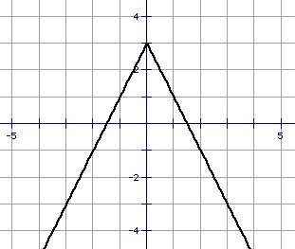
a.

b.

c.

d.

For problems 11 – 14, graph the absolute value equation.

11. 11. vertex: __________
axis of symmetry: __________
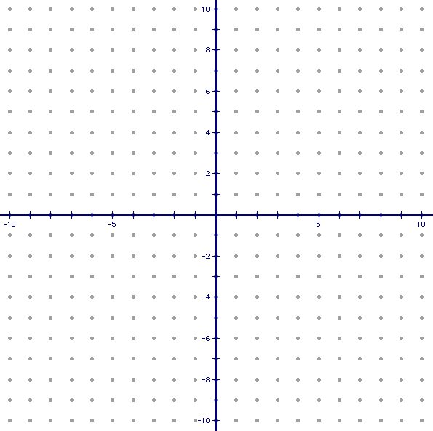

12. 12. vertex: __________
axis of symmetry: __________

13. 13. vertex: __________
axis of symmetry: __________

14. 14. vertex: __________
axis of symmetry: __________

For problem 15 – 18, use the following information to answer the problem.

15. A cereal manufacturer has a tolerance of 1.25 ounces for a box of cereal that is supposed to weigh 30 ounces. Write and solve an absolute value inequality that describes the acceptable weights for “30 ounce” boxes.

15. _____________________________

16. The length of a standard basketball court can vary from 84 feet to 94 feet, inclusive.
Write an absolute value inequality that describes the possible lengths
of a standard basketball court.

16. ___________________________

17. How many solutions are there to ? Explain why.

17. ___________________________
Explain: _____________________
_____________________________
_____________________________
_____________________________

18. The roof line of an A-frame home follows the path given by .

a. Find the vertex of the absolute value equation.

18a. ___________________________

b. What does the y-value of the vertex tell us about the home?

18b. ___________________________
___________________________
___________________________

